

#### HUMAN BIOLOGICAL SCIENCES STAGE 2

## **CIRCULATORY SYSTEM**

**EXTENDED RESPONSE**

Name: ___________________________________

1. The diagram below schematically represents the blood flow into and out of the heart.

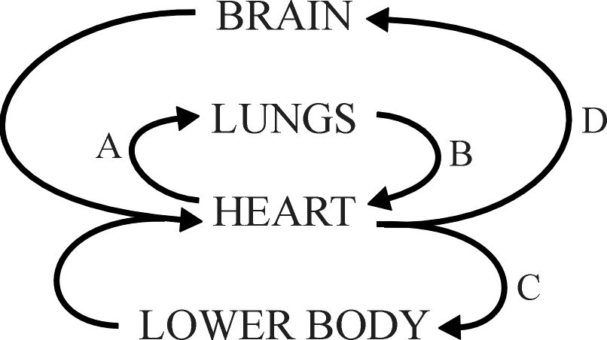

1. Blood taken from which part of the circulatory system (A, B, C of D) would have the highest concentration of carbon dioxide. [1]

**A**

1. Name blood vessel B. [1]

**Pulmonary vein**

1. Name the major blood vessel from which C and D branch. [1]

**Aorta**

1. Complete the missing labels on the heart diagram below. [3]

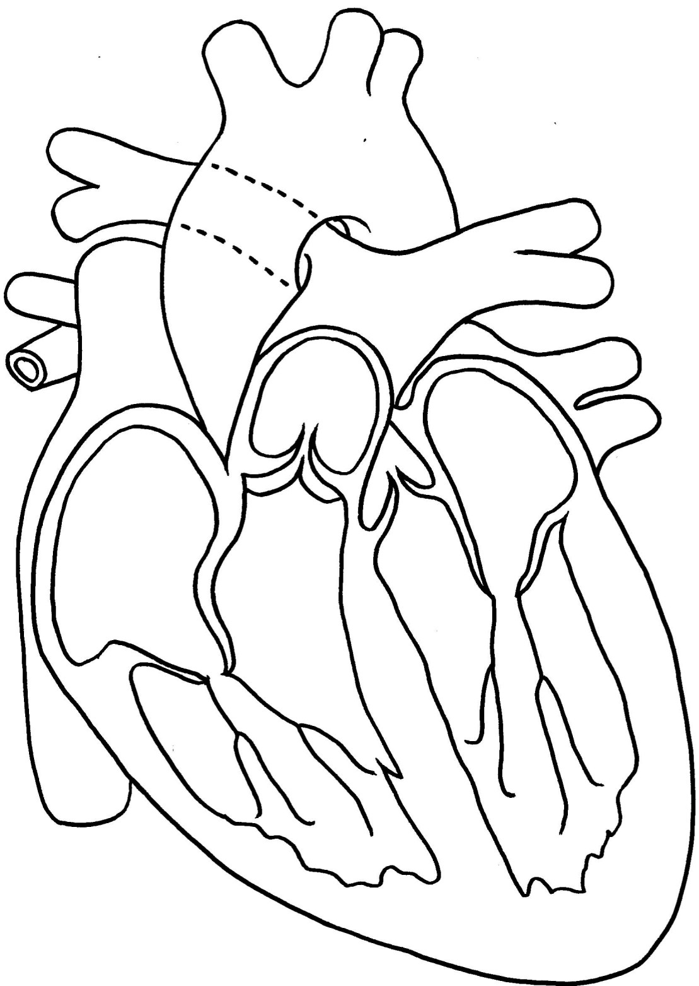

Valve

Chamber

Blood vessel

**(superior) Vena Cava**

**Left atrium**

**Right atrioventricular or**

**tricuspid**

1. The diagram below shows the internal structure of a normal and a diseased artery.

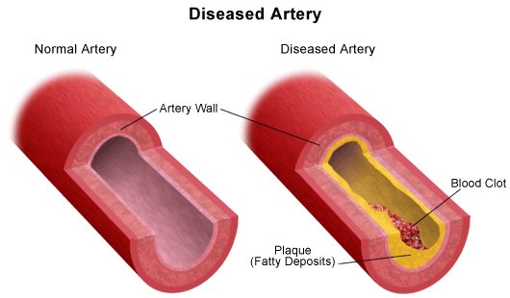

* 1. Describe two ways in which the wall of a normal artery is different to the wall of a vein. [2]

**Thicker wall**

**More muscular wall Any two points, 1 mark each**

**More elastic fibres in wall**

* 1. For each of the statements listed below circle whether it is true or false. [2]

1. Atherosclerosis is characterised by the formation

of plaque on the internal walls of arteries. **T** F

1. The formation of plaques increases the risk of

hypertension. **T** F

1. Smoking is one of the main risk factors for plaque

formation. **T** F

1. A stroke is caused when an artery supplying blood to

the heart is blocked. T **F**

1. Electrocardiograms can be used to measure heart rate and analyse the functioning of the heart.
   1. There are three main parts to an ECG – P-wave, QRS complex and T-wave. Label these parts on the ECG below. [1]

**T-wave**

**P-wave**

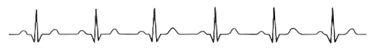

**QRS complex**

* 1. What is happening in the heart when each of these waves is formed? [3]

**P-wave = atria contract (depolarise)**

***QRS complex = ventricles contract (depolarise)***

***T-wave = ventricles relax (repolarise)***

* 1. Why is the P wave so much smaller than the QRS complex? [1]

**The atria have less muscle mass / electrical activity than the ventricles**

* 1. If the ECG trace above was taken over a period of 4 seconds, what was the person’s heart rate? [1]

**75 bpm**

1. Blood pressure in arteries is measured using an instrument called a sphygmomanometer. Explain in detail how you would use this instrument to measure blood pressure. Your answer should include information on the meaning of systolic and diastolic pressure. [5]

**Systolic – highest pressure caused by contraction of ventricles [1]**

**Diastolic – lowest pressure occurs the heart is relaxed [1]**

**Place cuff around arm / inflate until blood is cut off to forearm / place**

**stethoscope over brachial artery [1]**

**Slowly deflate cuff until sound of pulse is heard = systolic pressure [1]**

**Deflate further until blood is heard flowing continuously = diastolic pressure [1]**

1. Consider the following graph:

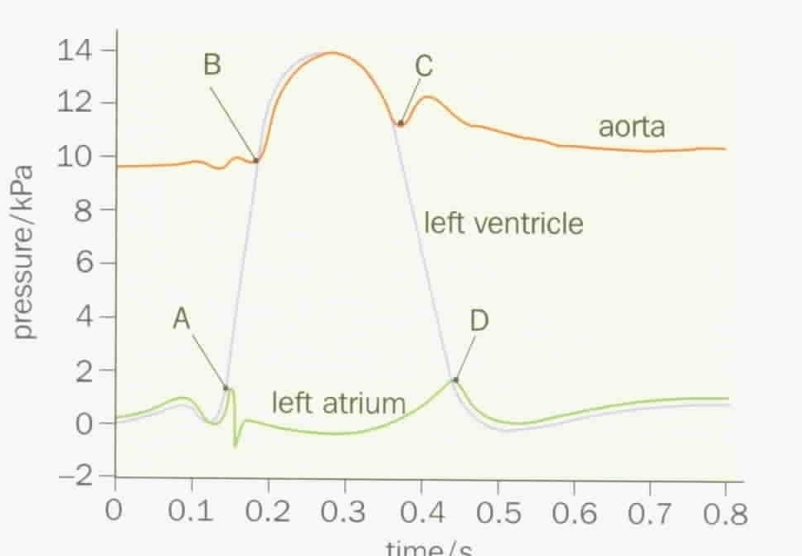

* 1. At point A the pressure in the left ventricle starts to exceed the pressure of the left atrium. What effect would this have on the left atrioventricular valve? [1]

**closes**

* 1. At point B the pressure of the left ventricle starts to exceed the pressure of the aorta. What effect would this have on the aortic valve? [1]

**opens**

6. Below is an image of a blood smear taken through a light microscope.

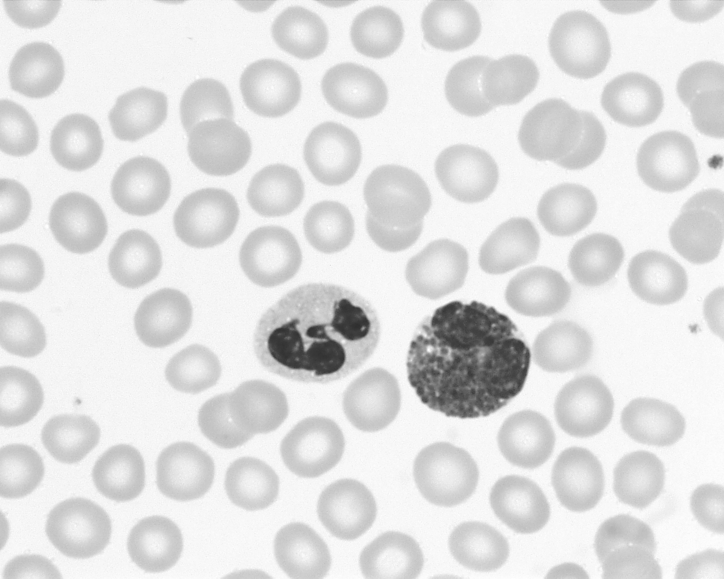

The cell identified by the arrow is a red blood cell.

1. Give two structural features of this cell that distinguish it from the two white blood cells. [2]

**Smaller size / no nucleus [1 mark each]**

1. Platelets are not easily identified in this image. Describe the function of platelets? [1]

**Help blood to clot**

**END of ASSESSMENT**